**Laboratory Five**



**Javier Jesús Macossay-Hernández**

**EE348L – Electronic Circuits**

**University of Southern California**

**Professor Susan Schober**

**Introduction**

In this laboratory, implementation of hand analysis and HSPICE simulations were done to understand the behavior of second-order high-pass filter (high-pass Sallen and Key filter). Furthermore, the filter was built in class and different tests were done to corroborate our hand calculations and simulation results.

High-Pass Sallen and Key Filter

**Procedure**

The filter was built using five resistors, two capacitors, and an LM741. A 3 kΩ resistance value was used for R1, 1 kΩ for R2, 5.8 kΩ for R4, 1 kΩ for Rx, and 2.3 kΩ for Ry. In addition, both capacitors were set to 25 nF. Finally, the voltage output was measured to corroborate the predictions from the pre-laboratory.

**Data**

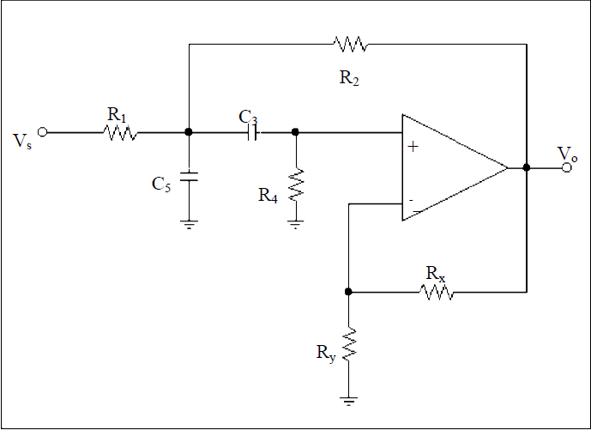

Schematic of the circuit

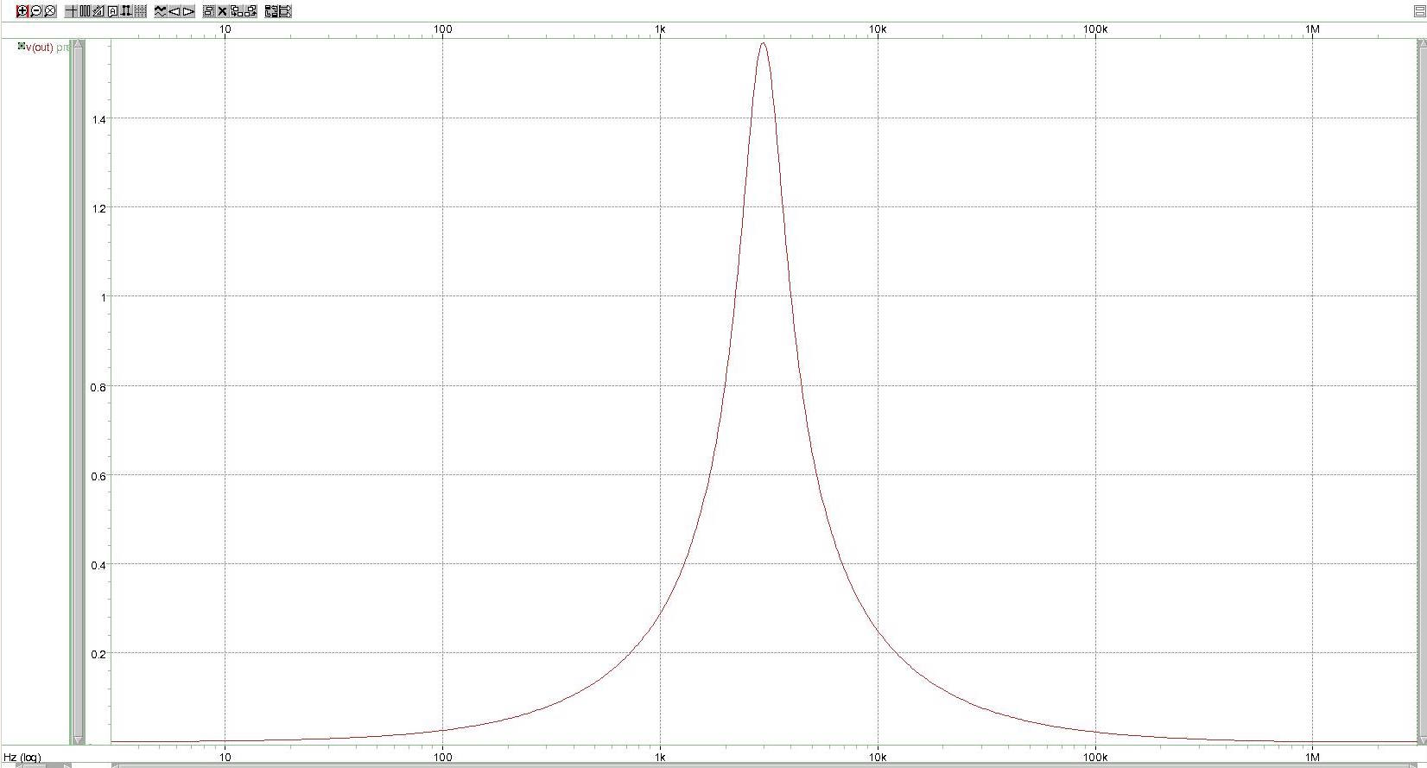

Result of the High-Pass Filter

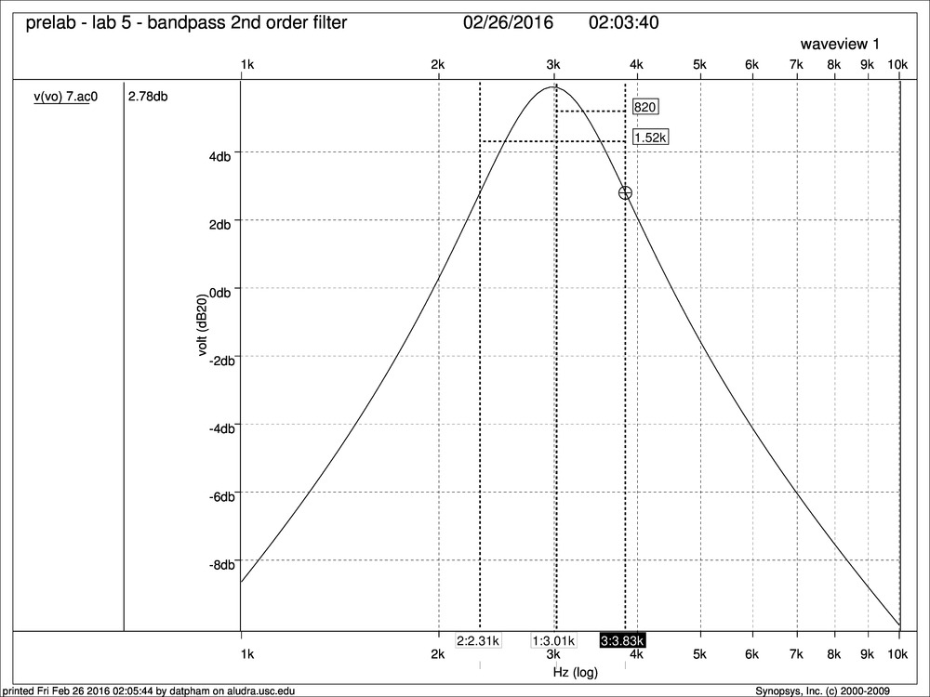

Result of the High-Pass Filter showing the Central Frequency and Bandwidth

**Questions**

The experimental results are similar to my predictions in the pre-laboratory section. The central frequency of the filter was 2.53 kHz, the gain was 2.103, the bandwidth was equal to 1.23 kHz (3.25 kHz - 2.02 kHz), and the quality factor “Q” was equal to 2.06.

**Discussion**

We had to build the filter two times because the first time we used the values of R1 equal to 30 kΩ, R2 equal to 10 kΩ, R4 equal to 12.4 kΩ, Ry equal to 10 kΩ, Rx equal to 14.3 kΩ, and capacitors equal to 5.5 nF the central frequency of the filter was 4 kHz. Our guess is that the capacitors with the incorrect values were placed in the 5.5 nF tray because we doubled checked our hand calculations and checked the values of the resistors and everything matched with the predictions, but the capacitor values could not be measured. Therefore, we changed the value of R4 to 21.5 kΩ and, since R4 is inversely proportional to the central frequency, the central frequency changed to 3.1 kHz and the final gain was 1.96. As a team, we opted to do a second design of the circuit and build it using values of capacitors that were available in the laboratory. The results from the laboratory experiments matched with the pre-laboratory results from the hand calculations. Therefore, the hand calculations and predictions were done correctly.

**Conclusion**

The results clearly agree with the objective of the lab that is to learn how second-order high-pass filter behaves. In addition, we use HSpice and WaveView Analyzer to corroborate our hand calculations and our measured values.